Make database

(database distribution of donation)

1. Make a database query

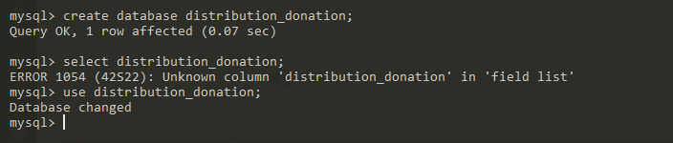

1. Query creation of each table

***Table sender***

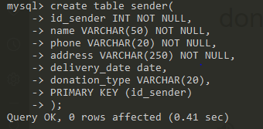

***Table admin***

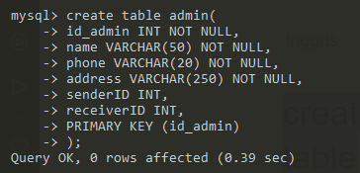

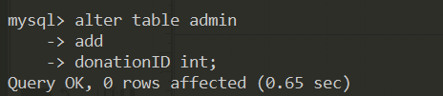

***Table receiver***

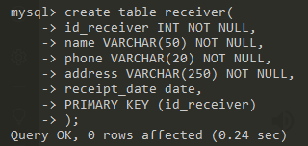

***Table donation***

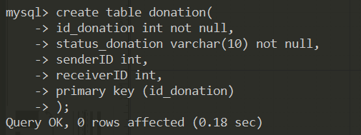

1. Query insert data

Insert into sender



Insert into admin

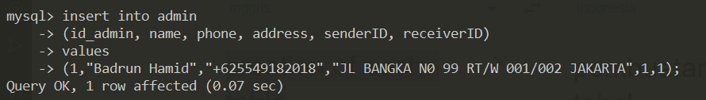

Insert into receiver

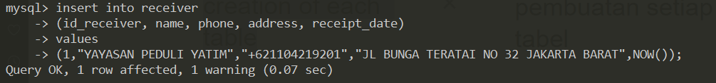

Insert into donation

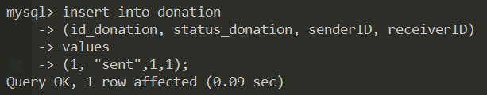

1. Query get data

Get data sender

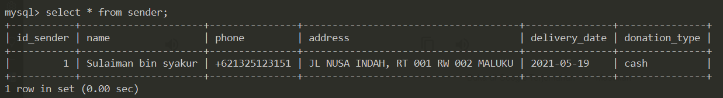

Get data admin

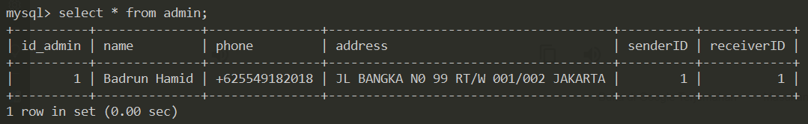

Get data receiver

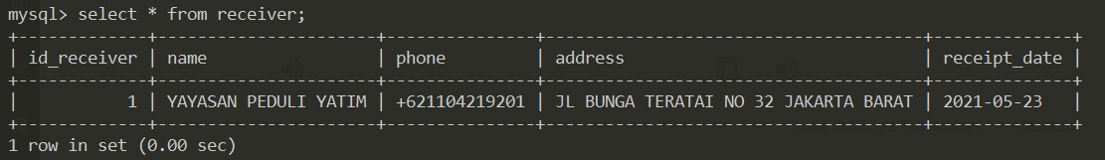

Get data donation

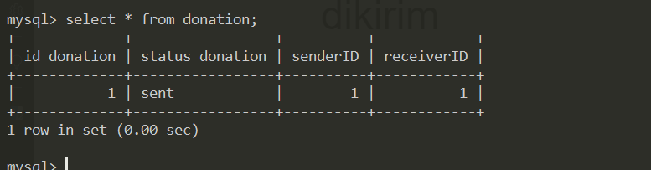

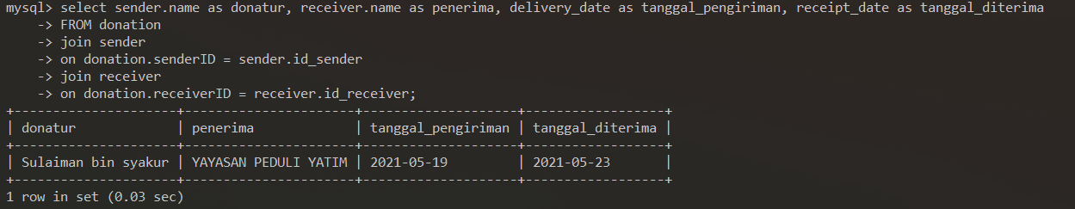

Relasi antar table



1. Erd & LRS

ERD

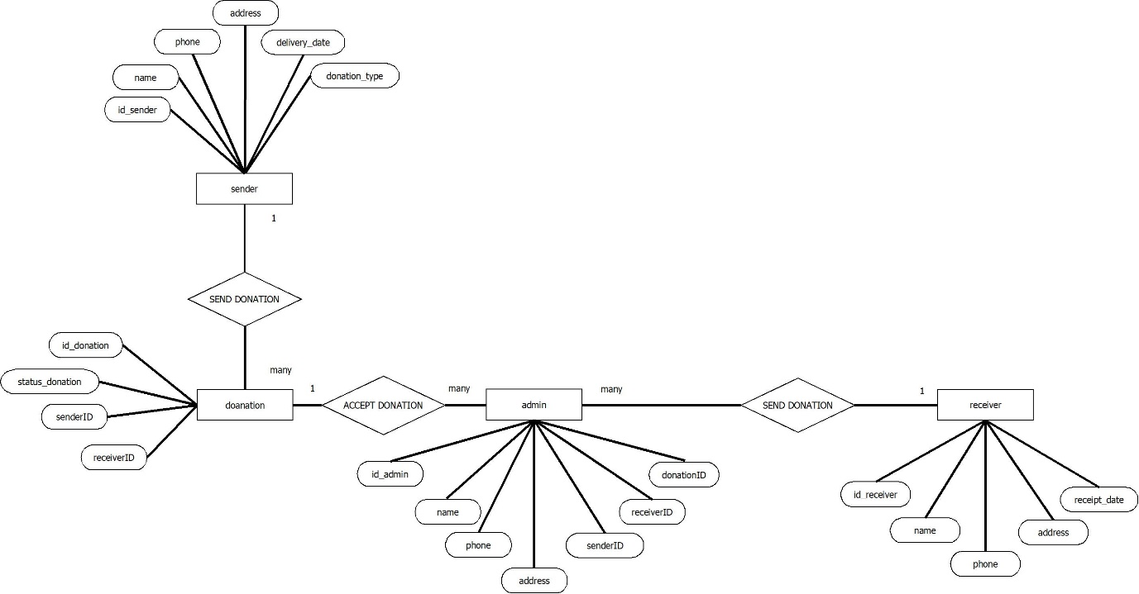

LRS

